**FRONT END UI/UX MINI PROJECT**

Group Member Details:

Name and Roll Number : Angel Shiju [2462538] ,

Tenzin Choeying [2462534] ,

Sai Arjun N [2462528]

Email: [angel.shiju@btech.christuniversity.in , tenzin.choeying@btech.christuniversity.in](mailto:angel.shiju@btech.christuniversity.in%20,%20%20%20%20%20%20%20%20%20%20%20%20%20%20%20%20%20%20%20%20%20%20%20%20%20%20%20%20%20%20%20%20%20tenzin.choeying@btech.christuniversity.in) , [sai.arjun@btech.christuniversity.in](mailto:sai.arjun@btech.christuniversity.in)

Course: Front End UI/UX

Class : 3 BTCS IOT

Instructor Name: Dhiraj Alate

Institution: Christ University

Date of Submission: 11-08-2025

DIGITAL BUSINESS CARD

Project Overview:

This project is a simple digital business card website created using HTML and CSS. It displays a profile image, name, a short description, contact information, and links to email, LinkedIn, and portfolio. The purpose is to present personal and professional details in a clean, easily accessible format.

Objectives:

- Design a single-page business card using HTML and CSS.

- Include personal details such as name, photo, contact info, and links.

- Apply basic styling and layout for a clean, professional look.

- Ensure the layout is centered and visually appealing.

Expected Outcomes:

- A fully functional digital business card web page.

- Ability to share contact information online with minimal effort.

- Practical experience in HTML structure and CSS styling.

Design Sections:

1. Profile Image

2. Name and Role

3. Description

4. Contact Information (Email, Phone)

5. Links (Email, LinkedIn, Portfolio)

6. Background image for visual appeal.

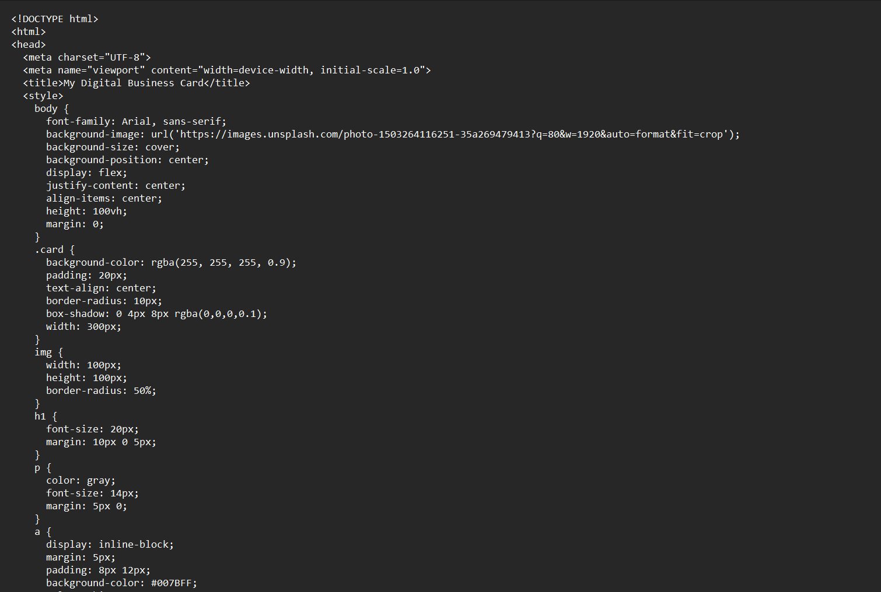Snippet of code

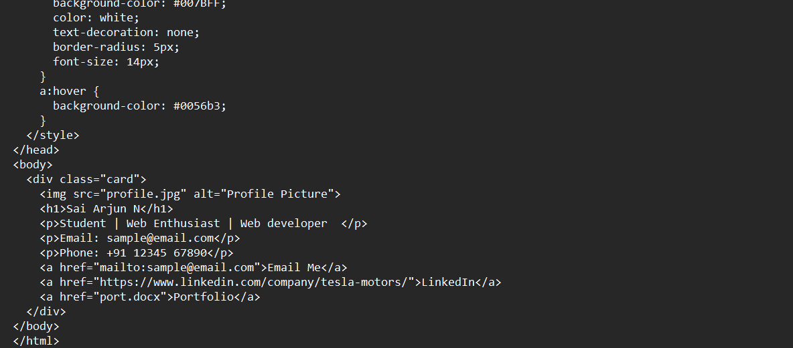

Screenshot of output Screen

